|  |
| --- |
| 新东方在线英语学习 |
| 新概念 1 册 |
| Lesson57-58 |



扫一扫。更多有趣的英语资讯。

# Lesson 57 单词讲解

1. o’ clock: 点钟，整点

8 点整：eight o’ clock 5 点整：five o’ clock

1. shop: 商店

The dresses in the shop are cheap.

这家店的衣服挺便宜的。

百货商店：department store（美）store（英）

1. moment: 片刻、瞬间

at the moment: 此刻

She is learning English at the moment. Wait a moment. = Wait a minute.

Lesson 57 课文讲解

1. It is…
   1. 天气；
   2. 点钟；
   3. 电话。

春天天气很糟糕。It is terrible in spring.

现在是 8 点整。 It is eight now.



是我，Venus.

It’s me, Venus.

2. The children go to school by car every day.

on foot- by bike- by bus- by car- by train- by air …

你是怎么去学校的？

How do you go to school?

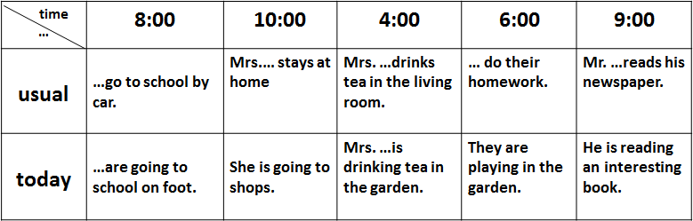3. But today, they are going to school on foot. are going to?

# Lesson 57 语法讲解

一般现在时 & 现在进行时

1. 使用情况不同
   1. 一般现在：习惯的状态、经常的动作、真理；
   2. 现在进行：此时此刻正在做、一段时间内一直。
2. 结构不同：
   1. 一般现在：主语+is\am\are, 主语+v.
   2. 现在进行：主语+ is\am\are + doing
3. 时间状语不同
   1. 一般现在：every…always, usually, often, sometimes…
   2. 现在进行：now, at the moment…

我通常 12 点吃饭，但今天都这会了，2 点才吃呢！

I usually have lunch at 12:00.

But I am having lunch now at 2:00.

# Lesson 58 单词句型讲解

**Lesson 57&58 知识拓展**

1. 省读:

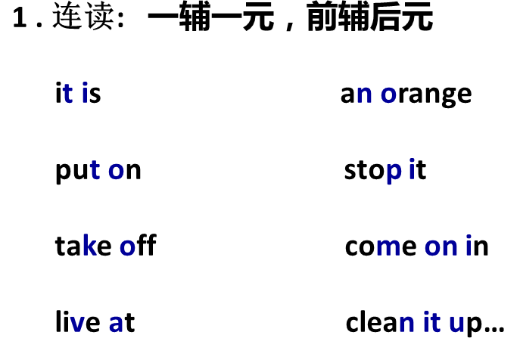

sit down part-time

big cake but now

good morning not that one

good night bookcase

Dad told me…

第一个单词的最后的字母和第二个单词第一个字母都是辅音

1. 口语习惯:

I am going to sit down on the grass. I’m gonna sit down on the grass.

I want to put on my shirt. I wanna put on my shirt.